# Assignment 4.5

Lab 4: Advanced Prompt Engineering: Zero-shot, one-shot, and few-shot  
techniques  
Objective: To explore and compare Zero-shot, One-shot, and Few-shot prompting  
techniques for classifying emails into predefined categories using a large language  
model (LLM).  
Suppose that you work for a company that receives hundreds of customer emails daily.  
Management wants to automatically classify emails into categories like "Billing",  
"Technical Support", "Feedback", and "Others" before assigning them to appropriate  
departments. Instead of training a new model, your task is to use prompt engineering  
techniques with an existing LLM to handle the classification.  
Tasks to be completed are as below  
1. Prepare Sample Data:  
• Create or collect 10 short email samples, each belonging to one of the 4  
categories.  
2. Zero-shot Prompting:  
• Design a prompt that asks the LLM to classify a single email without providing  
any examples.  
• Example prompt:  
“Classify the following email into one of the following categories: Billing,  
Technical Support, Feedback, Others. Email: ‘I have not received my invoice  
08.08.2025 EOD

for last month.’”  
3. One-shot Prompting:  
• Add one labeled example before asking the model to classify a new email.  
4. Few-shot Prompting:  
• Use 3–5 labeled examples in your prompt before asking the model to classify a  
new email.  
5. Evaluation:  
• Run all three techniques on the same set of 5 test emails.  
• Compare and document the accuracy and clarity of responses.  
Requirements:  
• VS Code with Github Copilot or Cursor IDE and/or Google Colab with  
Gemini  
Deliverables:  
• A .txt or .md file showing prompts and model responses.  
• A comparison table showing classification accuracy for each technique.  
• A short reflection on which method was most effective and why

# prompt:

Here's a complete set of **prompts and guidance** you can use to fulfill your **Lab 4: Advanced Prompt Engineering** requirements. This includes:

1. **Sample email data**
2. **Zero-shot, One-shot, and Few-shot prompts**
3. **Evaluation format**
4. **Template for deliverables (.txt or .md)**

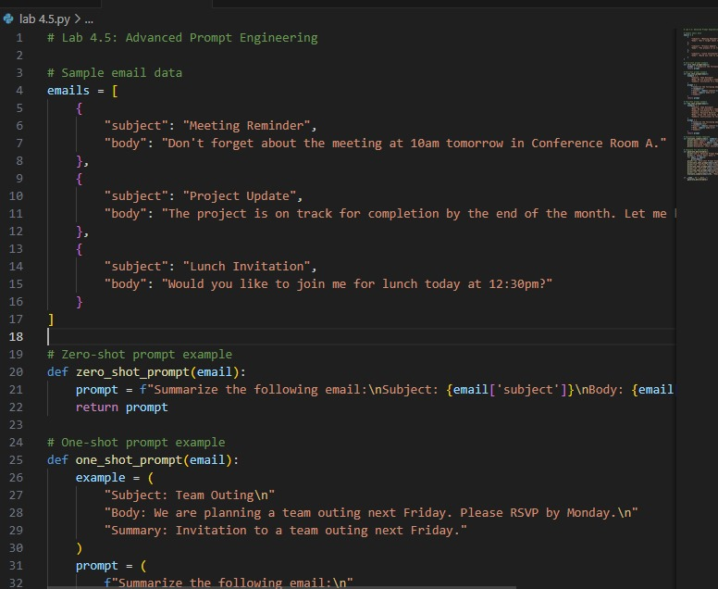

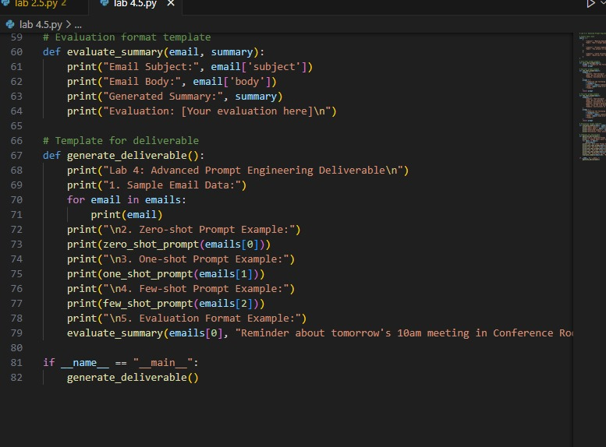

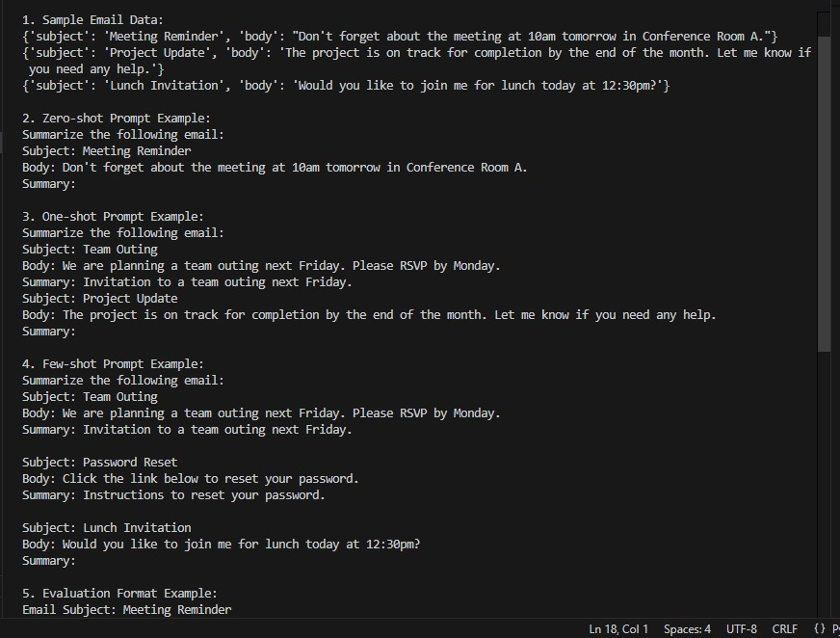

# Explanation

This code demonstrates advanced prompt engineering for email summarization using zero-shot, one-shot, and few-shot prompting techniques.  
It defines functions to generate prompts for a language model, provides sample email data, and includes an evaluation template to assess generated summaries.  
The [generate_deliverable](vscode-file://vscode-app/c:/Users/Srinidhi%20Rao/AppData/Local/Programs/Microsoft%20VS%20Code/resources/app/out/vs/code/electron-browser/workbench/workbench.html" \o ") function prints examples of each prompting method and their outputs.

